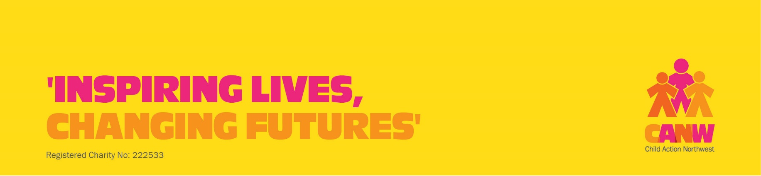
Ribble Valley IAPT Adult Self-Referral Form
This form is for referral into the Ribble Valley IAPT service provided by CANW. We provide counselling and low intensity CBT for adults (from age 16) who are experiencing common mental health problems. This is not an emergency service.
For an electronic version of this form, please email: EHWBreferrals@canw.org.uk.
Please complete the form below and email is to: EHWBreferrals@canw.org.uk.
Alternatively you can post it to Ribble Valley IAPT Service, CANW, Whalley Road, Wilpshire Blackburn BB1 9LL.
When we receive your form we will contact you by telephone to arrange an appointment.
Full Name:  Gender: | Date of Birth:  NHS no (if known)
Address:  Postcode: | Contact details: Please indicate if we can leave a message on voicemail or answerphone  Home phone………………………….……………. Yes/No  Mobile phone………………………………………. Yes/No  Email address:
Preferred language:

Do you have a disability or long term health condition? Yes/No
Please give details:

Are you or your partner pregnant or had a baby in the last 2 years? Yes/No

Have you served in the armed forces? Yes/No

GP name and address:

GP phone number:

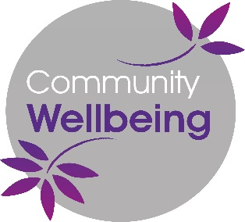
Please contact me by telephone or letter to arrange an appointment

Signature: …………………………………………………………………

Date: …………………………………………………………………………

